Preface 2
1. Executive summary 3
Part A – The challenge 4
The “Trees in need” challenge: incidence of urban tree failure in Amsterdam 4
insert 4
Method: Boombrix pilot project location and trees 4
insert 6
Trees in streetscape setting 6
Trees identified as “at risk” 7
Common tree species in Amsterdam 8
Location of Boombrix IoT device 9
Method: Data acquisition and handling 9
insert 10
NDVI as an indicator for tree vigour 10
Pilot timing and effects on data collection 10
Results: Boombrix pilot findings 11
Pilot data results 11
Datasets analysis 11
Comparison of precipitation and soil moisture in the period with best soil moisture data coverage 12
Distribution of soil moisture per device/tree 13
Proportions in soil moisture on different sensing levels 13
NDVI results 14
Pilot sensing 15
Analysis: Pilot data and observations 16
Resilience of pilot trees 16
Effects of tree pit growing conditions on moisture 16
Effects in control tree 16
Relevance to current environmental issues and policies 16
Conclusions from pilot project 16
Redefine the challenge “Trees in need” 16
Redefine “at risk” trees 17
Growing conditions 17
We can point to widening participation 17
Possible further research questions 17
Conclusions 17
Part B – SiRA component 18
Startup In Residence Amsterdam (SiRA) program 18
Boombrix and the SiRA pilot project 18
Boombrix and the “Trees in Need” SiRA challenge 18
Trees in need: SiRA findings 18
Training summary 18
Innovation in tackling urban sustainability challenges 18
Value of SiRA training in the case of Boombrix 18
Value of SiRA case owners 19
Challenges to startup activities in the SiRA programme 19
Summary of findings and recommendations 19
Appendices 19
Boombrix, Project Plan prepared for Startup In Residence program. Issued 8th August 2019. 20
Review on Boombrix Project Plan post-Pilot. 21
Municipality of Amsterdam, Startup In Residence Tender “Trees in need” challenge description. 22
SiRA pilot resources 24
Boombrix device up-scaling analysis 25
“At risk” trees: comparison of identification method 26

Preface
Boombrix is a startup founded by Noelle Teh and Jakub Supera in January 2019 and is dedicated to creatively using technologies to address environmental challenges facing trees in the city. Noelle and Jakub worked to establish a business case and non-commercial pilot while undertaking their Masters programme (joint degree between Wageningen University and Research and TU Delft) at the Amsterdam Institute for Advanced Metropolitan Solutions (AMS Institute) and in April 2019 entered as Boombrix for the 2019 SiRA programmeme. In May 2019 Boombrix was officially notified that it had been accepted into the SiRA programmeme.
Since then, Noelle and Jakub have attended training sessions organised by the SiRA programme in parallel to establishing the pilot plan that gave rise to this report. This report is comprised of two main parts: the pilot project findings and the SiRA programmeme findings where the former is the outcome of the latter.

1. Executive summary
In the face of climate change, the municipality of Amsterdam strives to achieve greater sustainability and resilience to ensure that the city’s liveability now and in future years. An example of this commitment can be seen in the decision to create a “Sustainability” themed 2019 Startup in Residence Amsterdam (SiRA) programme. Various departments from within the municipality submitted sustainability-related challenges for startups to consider and, when applicable, pitch their startup’s idea/business for selection by the SiRA programme committee. Of over 100 applicants for 13 challenges, 10 startups and 10 challenges were successful in their bid.
[something more re: BB and the trees in need challenge 2-3 sentences]. This report summarises the findings of the “Boombrix Pilot” project and is the result of information shared between Boombrix and the Municipality of Amsterdam’s “Green asset management” during the period of the SiRA programme (May 2019 to December 2019).
This report is the principal output of the Boombrix pilot project and describes results that demonstrate how startups (and the SiRA programmeme) can assist in ongoing municipal efforts to increase sustainability and improve the longevity and vigour of Amsterdam’s trees. The first part of this report is focused on the pilot project’s location, results, and implications for the Green Asset Management team. The second part of the report focuses on the SiRA programmeme (through the experiences of Boombrix) in terms of its value to municipal departments and sustainability challenges in the city.

Part A – The challenge

The “Trees in need” challenge: incidence of urban tree failure in Amsterdam
Amsterdam is home to over one million trees (excluding Amsterdam Forest). The city’s public spaces and roads are lined with trees wherever possible and provide the city with a vibrant green canopy that provides much needed shade in warmer months. Amsterdam’s trees give citizens more than climate relief: trees provide visual amenity and add to citizens’ sense of wellbeing.
This relationship between citizen, city, and tree is now at risk due to the changing climate that has reduced annual averages of rainfall while also increasing annual averages of temperature. This combination of less water and warmer days has resulted in increased tree failure due to the inability of some trees to withstand different growing conditions.
Increased tree failure is already occurring at a rate that has drawn attention across municipal departments and the public: in the summer of 2018 the municipality estimated that 25 to 50 percent of plants (including trees, shrubs, perennials, and lawn) were lost. This was despite the municipality spending €475,000 on additional watering. The cost of replacing the plants has been estimated to be in the region of 1.4 million. It should be noted that this amount is to install new plants to replace, not add to, plants that were lost.
Costs to the municipality are not limited to the replacement of plants. Weak trees are also prone to uprooting and falling in windy conditions – this is particularly hazardous in densely populated urban areas like Amsterdam where people, houses, and cars are in close proximity to trees. The health of Amsterdam’s trees is vital not only for prolonging the benefits (or ecosystem services) that trees provide but also to reduce the risks to public safety and property.
What is described in this section forms the foundation for the Municipality of Amsterdam’s “Asset management, Traffic and Open Space” department to issue the “Trees in need” challenge for the sustainability focused 2019 Startup in Residence program. The aim of having the “Trees in Need” challenge was to reduce water waste by knowing when and where to water the trees and to ensure the appropriate amount of water is used. Additional aims included informing future tree species planning, data collection for risk management, and visible improvement to 90% of all trees in public space to achieve a “CROW standard B” by 2025. Since the challenge was issued, the municipality has revised the CROW standard to “CROW standard C”.
Boombrix was the SiRA startup selected for the “Trees in need” challenge. Boombrix’s mission is to use technology to address the challenges facing urban street trees. In the case of the “Trees in need” challenge, an IoT soil moisture sensor is placed in the root zone of an individual tree and reads soil moisture at multiple depths to sense the presence and movement of moisture through the soil horizon. This on site knowledge is then combined with other forms of urban data with the goal of providing insights to clients on which trees need watering and when.

Method: Boombrix pilot project location and trees
During the SiRA programmeme, startups were encouraged to undertake a pilot project for their challenge. Boombrix responded to this by planning a pilot project together with Jaike Bijleveld, case owner and department representative for the “Trees in need” challenge. This process began in June 2019 and the pilot activities starting in July 2019 at the approval of the case owner and SiRA team.
The overall aim of the pilot was to test the possibilities of Boombrix’s value proposition to the municipality – how could IoT devices and urban data be combined to provide insights into the watering needs of trees in the city? To try and simulate the realities of Amsterdam’s urban environment the location for the pilot was decided upon using the following criteria:
- Must be a street that exhibits a streetscape typology typical to Amsterdam (refer to section 2.1 for details);
- Must contain individual trees identified in the municipality’s “at risk” tree register (refer to section 2.2 for details);
- Must contain tree species that are common to Amsterdam’s streets (refer to section 2.3 for details);
- Preferably within a convenient and accessible location for the case owner and Boombrix.
After analysis of the municipality’s “at risk” tree register, it was decided to conduct the pilot on Rapenburgerstraat, a predominantly residential street that is approximately 18 metres in width and located in the Valkenburg district. Rapenburgerstraat fulfilled all four criteria; trees on site were of the common Ulmus Elm species, eight of which were classified as “at risk” trees in a row along the southern side of the street. One additional non-“at risk” tree in that row was selected to be used as a point of reference.
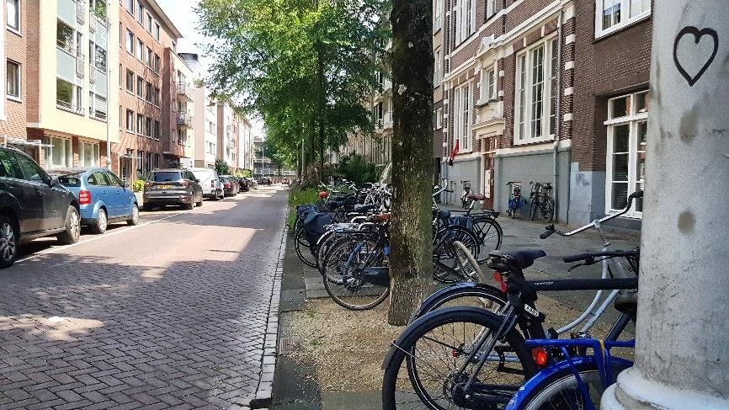
Also of note is that two “at risk” trees were growing in a garden bed that functions as “biodiversity planting” for the street. This type of garden bed has been installed sporadically throughout Amsterdam and is part of wider efforts by the municipality to increase biodiversity in the city.
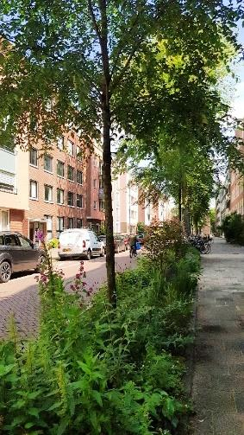
The plan drawing below shows the relationship between the trees and the street in the pilot site:

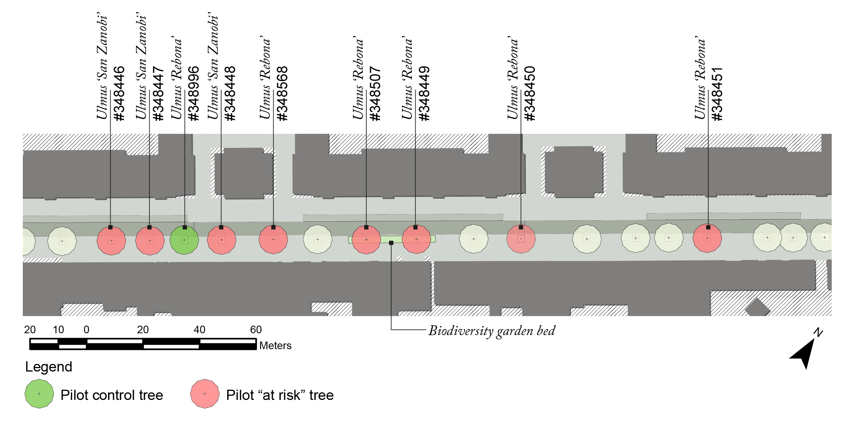
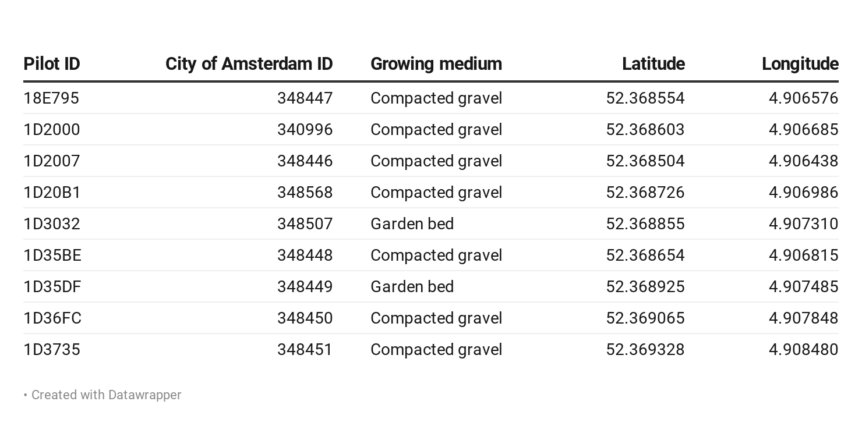

Trees in streetscape setting
Trees growing in the pilot site were growing in conditions that are typical to Amsterdam: a tree pit that is filled with soil and covered with a permeable gravel surface that is lightly compacted. As previously noted, some tree pits do not have this gravel topping and are instead planted with plants that enhance the biodiversity potential of that area. The table below sets out these types:
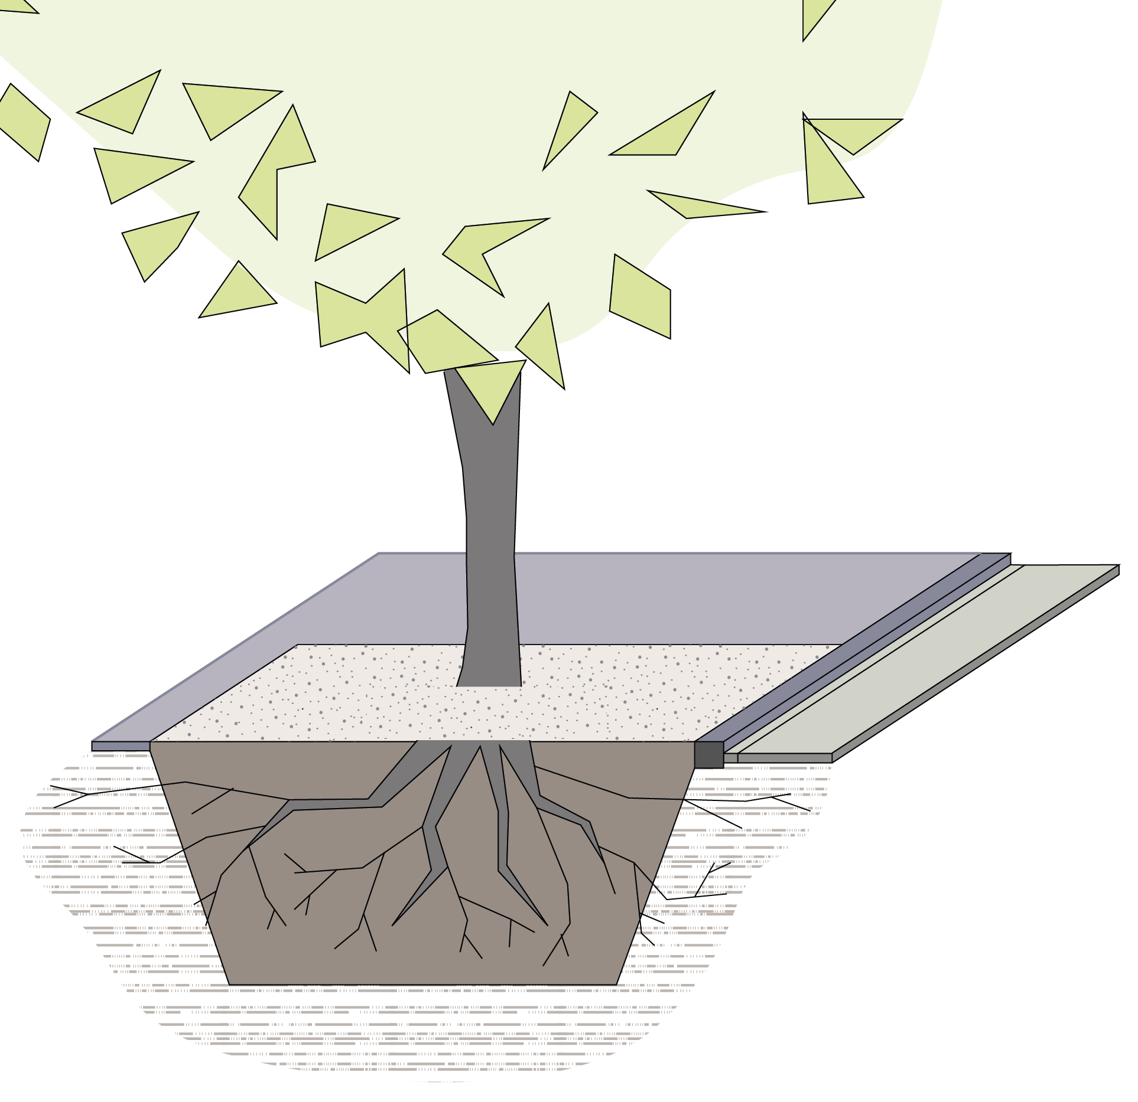 | Typical tree pit  Surface: compacted cementitious gravel  Soil: sandy loam  The compacted gravel surface is an approximately 3-4cm thick layer that prohibits erosion of the soil below. Site observations show that the gravel surface also inhibits surface water from reaching the soil.  It was also noted that the soil below the gravel lacked any visible soil biota.
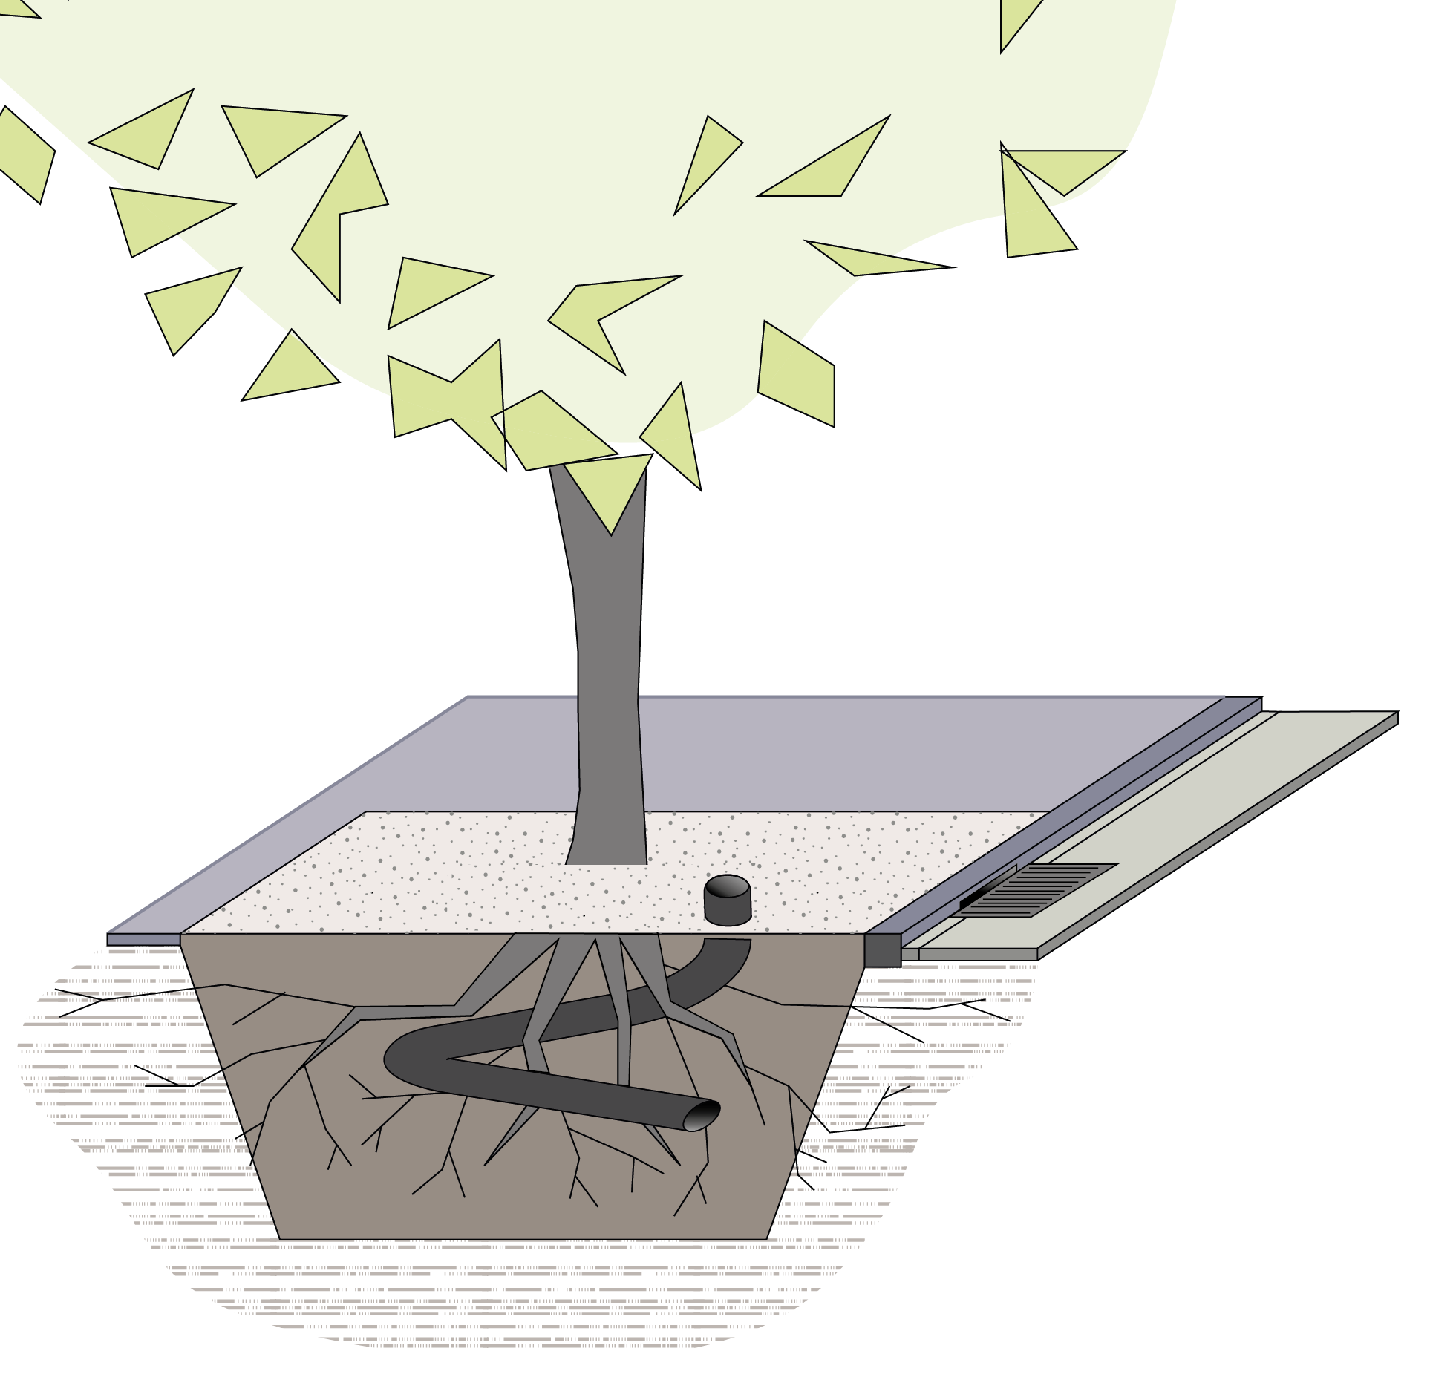 | Typical tree pit with additional infrastructural elements  Surface: compacted cementitious gravel  Soil: sandy loam  In some cases, trees are located at the same point as side-inlet grates for road drainage. It was observed on site that water tended to pond in these areas and could be slowly infiltrating through kerbstone joints and cracks.  A slotted PVC pipe has been installed at the base of some trees and its specific use is unclear. Typically slotted PVC pipes are used to ensure air or water reach the root ball and lower levels of soil. In some cases proprietary products can be installed that are designed for both air and water but it is unlikely that such a product has been used in the pilot site.  The inlet of the slotted PVC pipe is installed above the finished surface level of the gravel and is prone to being filled with rubbish – accidentally or purposely – by citizens who are unaware of its vital function for the tree.
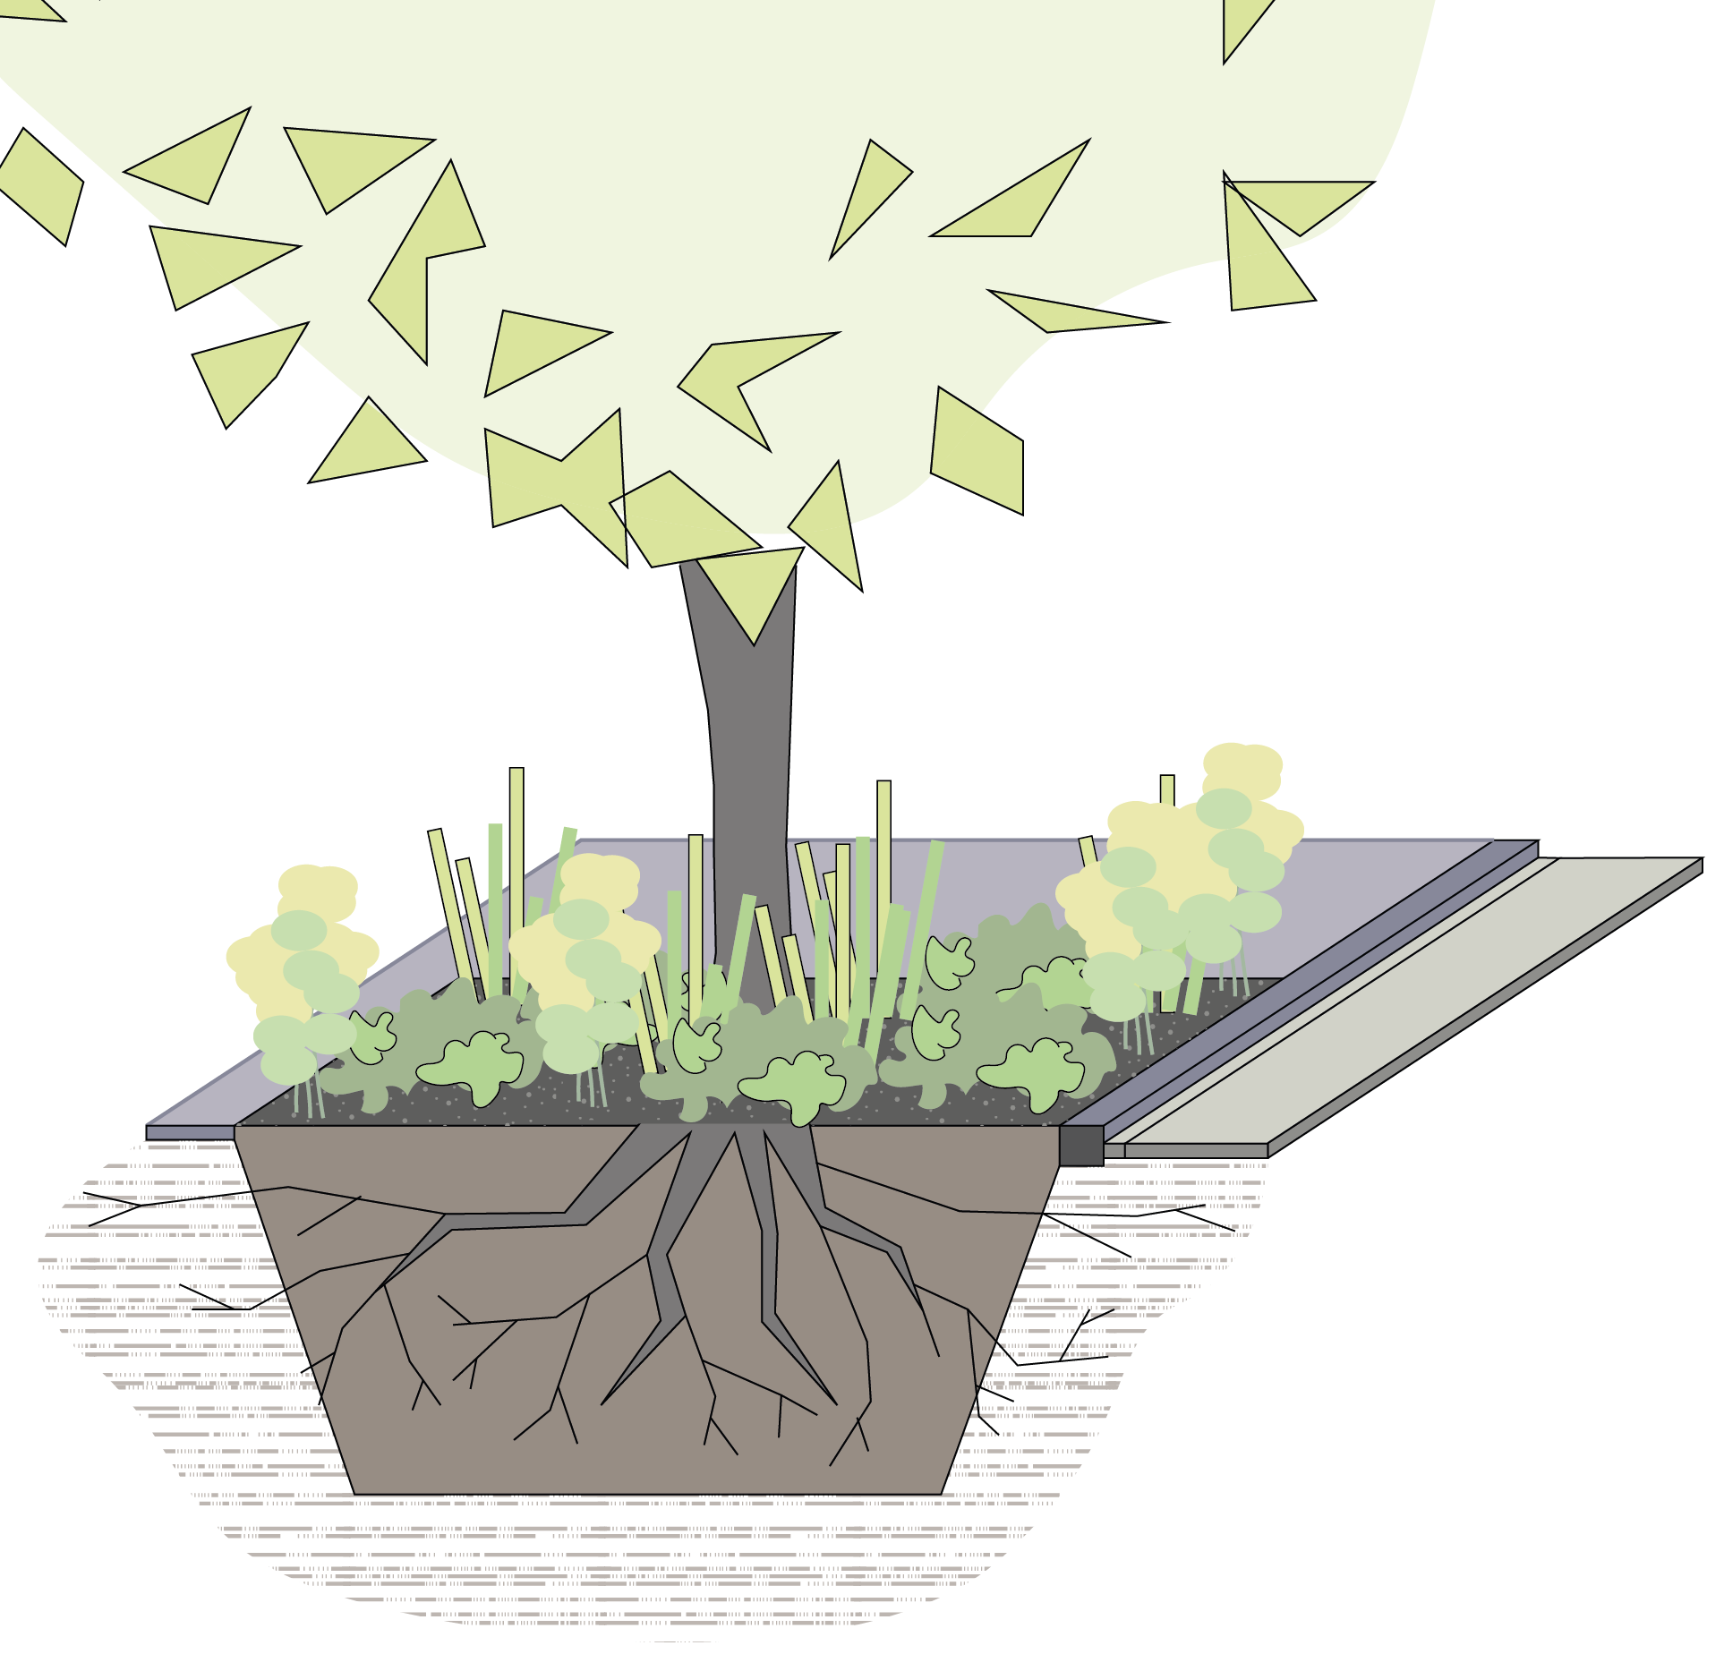 | Biodiversity garden tree pit  Surface: topsoil with shrubs and groundcovers  Soil: loamy sand  Biodiversity gardens below street trees are an infrequent condition in the rest of the city. The difference in soil quality in comparison with the typical tree pit is remarkable – soil biota was visible and abundant. The soil was noticeably darker with organic matter and appeared to retain more moisture as a result.

Trees identified as “at risk”
“At risk” trees are trees that have been identified by the case owner’s department as being more susceptible to periods of prolonged drought and heat. The trigger for this classification was the unusual and extended drought period in 2018 which resulted in the plant failture mentioned in the “Trees in need” challenge.
Trees that were assessed excluded those in “boscplantsoen” (forest planting) as they grow in conditions that are not typical to the urban environment. This resulted in a shortlist of approximately 300,000 trees from the approximately 1,000,000 trees in total. Of the 300,000 trees in the shortlist, a further classification was performed to shortlist trees that were outside of the municipality’s guarantee period from the various sub-contractors that are engaged to plant new trees.
This list was generated using certain criteria against the list of trees contained in a management software that is currently in use by the municipality. Specifically, the age of the tree (less than five years old) and the diameter of the trunk when measured at breast height (less than 20 centimetres). The map chart to the left shows the distribution of these trees across the neighbourhoods of Amsterdam.

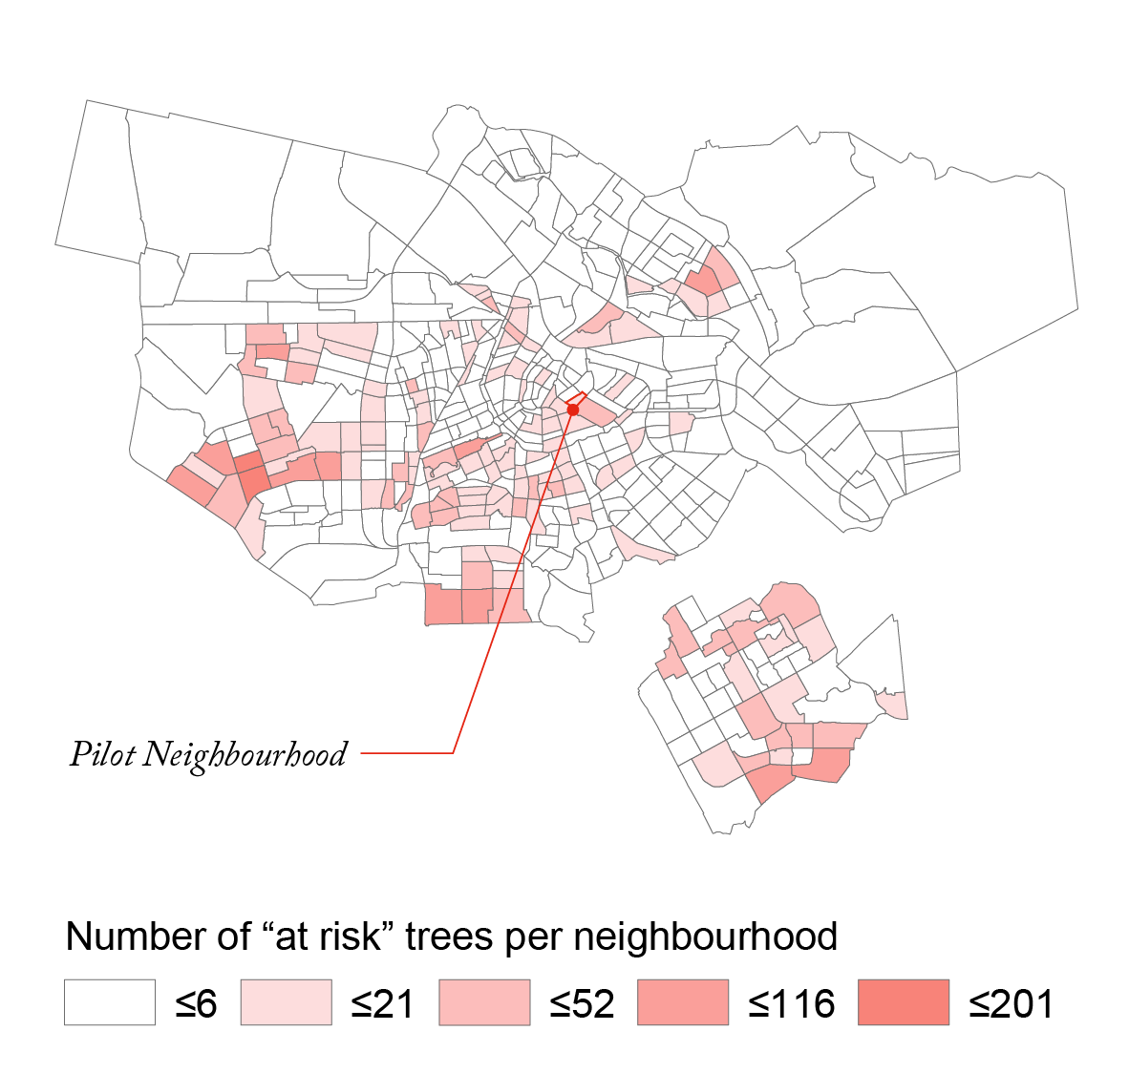 | 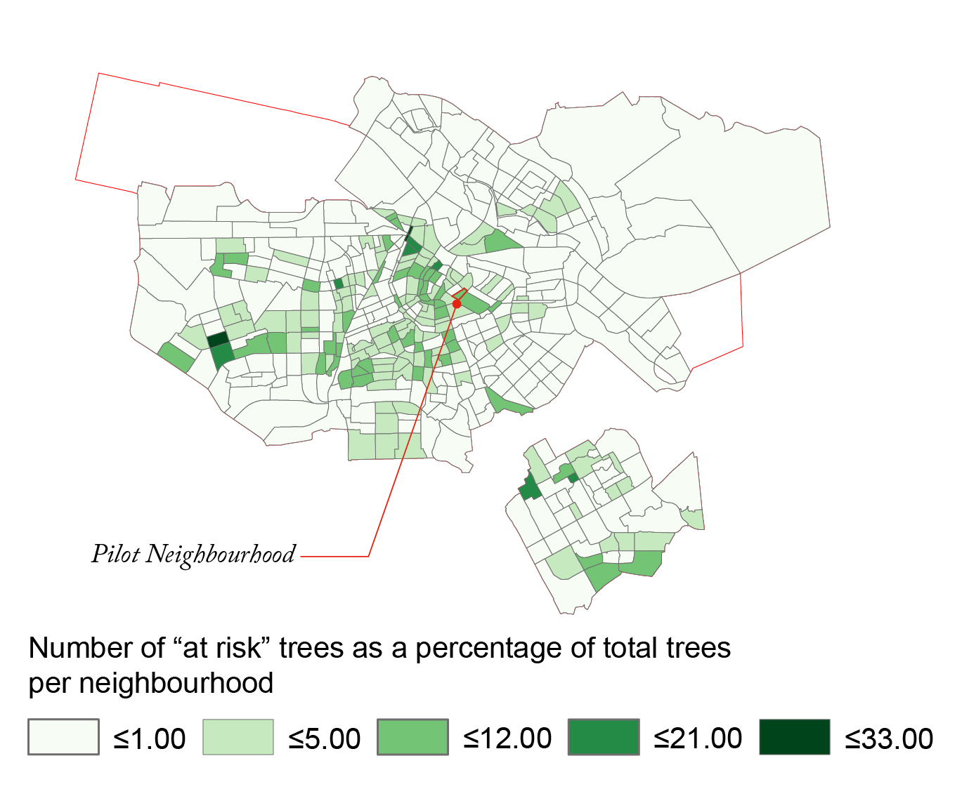
As can be seen in the map chart above, the pilot neighbourhood does not contain the highest number of “at risk” trees, it is still valuable to conduct the pilot in this area because the inner city neighbourhoods of Amsterdam also have the least number of trees per neighbourhood. | The map chart above shows the “at risk” trees as a percentage of the total trees in a given neighbourhood. This map demonstrates that when considering which neighbourhoods contain the most “at risk” trees, the total number of trees should be included to better understand the risks to the total population of trees within a district.

Common tree species in Amsterdam
In meetings with the case owner, the common tree species of Amsterdam were frequently mentioned. None more so than the Ulmus or Elm tree species that are ubiquitous in the municipality and synonymous with Amsterdam’s image as a city. To increase the potential relevance of the results, it was preferred to select trees that were in the top five species.
For the pilot, the “at risk” tree list was analysed. It contains 3,866 trees of which 54 tree genera are represented. Within this list the “top 5” trees of Amsterdam are present: Tilia, Ulmus, Acer, Prunus, and Platanus species. Boombrix reviewed the list and found that there were two additional species that had higher “at risk” populations than those in the “top 5” list: Sorbus and Gleditsia were also included. The actual percentage of certain genera within the “at risk” list is as follows:
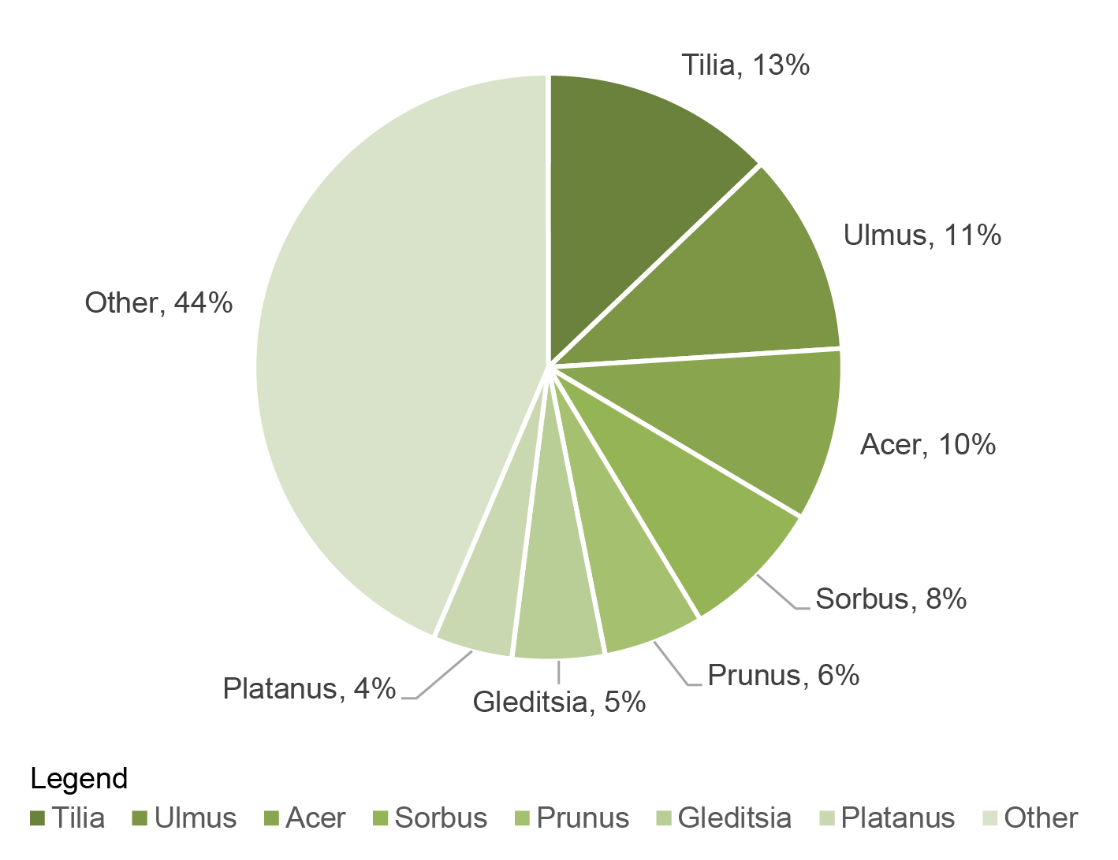
When considering the largest population of trees according to genus or species, the data from existing tree management lists can shed more light on the changing population sizes of various genera – this may assist in future decision making when planting new trees.

Location of Boombrix IoT device
The unique service that Boombrix offers is that basic soil moisture data can be wirelessly collected at the location of an individual tree. The IoT device designed by Boombrix is installed with its probes and controller underground and is not visible from the surface. At a meeting with the case owner and other stakeholders of the “Trees in need” challenge, it was recommended that the depth of the probe should be at least 50cm below the surface level and ideally lower.
The Boombrix IoT device was designed according to general aboricultural advice that a tree’s roots (for water) are distributed in the upper layers of the soil. Also, as the Boombrix device was designed to be installed with minimal intrusion and damage to the root zone it was decided to proceed with the depths of 30cm, 20cm, and 10cm instead. The value of the data in this case was the monitoring of infiltration through the soil horizon. Due to the length of the sensing period it was anticipated that disturbance to the soil would settle sufficiently to provide useful insights.
Going forward, further research and development is required to design the sensor to be placed at lower depths and this will be balanced with the quality of the IoT connection.

Method: Data acquisition and handling
Boombrix’s approach to the “Trees in Need” challenge is to use an IoT device that can sense soil moisture. The hardware for the sensor is at a prototype stage and is designed to be waterproof to protect the device’s electrical parts. The moisture sensors protrude from the casing and each probe is placed at varying depths in the soil. For the pilot three moisture sensors were used and located at depths of approximately 30cm, 20cm, and 10cm.
The soil moisture readings are sent via the SigFox network to a cloud database that is accessed when needed by Boombrix. The soil moisture data is then combined with urban data from other sources including the Royal Dutch Meteorological Institute (KNMI), and the European Space Agency (ESA). Climate data and Normalised Difference Vegetation Index (NDVI) are taken from these sources respectively. Both the KNMI and ESA provide developers (includes startups like Boombrix) with access to this data.

NDVI as an indicator for tree vigour
The data collected by Boombrix is a balance of tree-specific and regional data. The soil moisture and NDVI readings are specific to the location of the tree and give insight into the growing conditions (measured as moisture in soil) and the tree’s behaviour to its growing conditions (measured as NDVI).
NDVI is an established and industry accepted indicator of plant health. Its application for measuring urban tree vigour is relatively recent as NDVI has been mainly used for monitoring agricultural plots. The image below summarises how NDVI values can be interpreted.
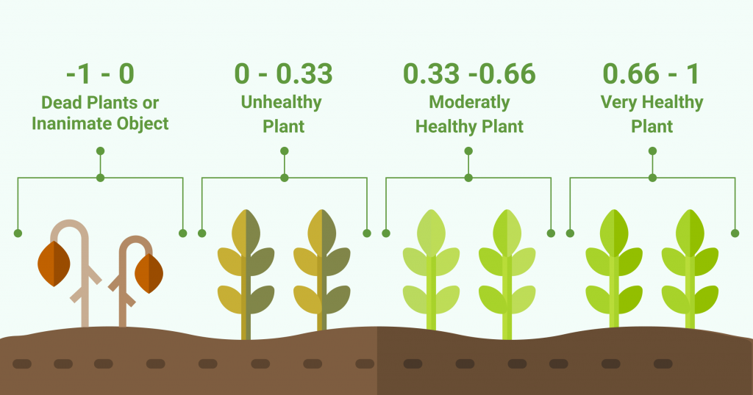
Explanation of NDVI values. Image credit: EOS.com
For the SiRA pilot NDVI is used to measure what response a single tree has to moisture in the soil in combination with rainfall events and temperature.
The data obtained and processed by Boombrix is used to generate a classification of the trees that is to be sent as a report to the client (in this case the Municipality). The classification of the tree is based on the insights gained from the data and indicates levels of action required to mitigate risk of tree failure.

Pilot timing and effects on data collection
Due to the SiRA programme starting in May 2019, the pilot project could not commence at the ideal time for monitoring the response of trees in their growing seasons. As such, the pilot plan focused on testing the up-scaled prototype device to ascertain its performance in “real-life” conditions in the city (refer to appendix for device up-scaling analysis).
With the learnings from this first pilot it is anticipated that a future pilot will start at the beginning of spring in April/May and that what is known now about the capabilities of the device will be resolved by that time. Nevertheless, the pilot project was important for the purposes of testing the abilities of the device and data in the context of what was learned about the municipality’s operations.

Analysis
Based on the methods set out in previous sections, the pilot collected data for all 9 of the trees identified for the pilot project. In addition to the data collected by the device and other sources of urban data, Boombrix also collected site data on the growing conditions of the pilot trees.
For the purposes of the pilot we collected data from:
- KNMI on precipitation, temperature and humidity (station Schiphol),
- ESA on NDVI index,
- Boombrix’s prototypes of soil moisture sensing units on soil moisture.
Our research questions considered possibility of differentiating growing conditions of trees including soil moisture as measurement of site specific conditions and NDVI as reference for trees’ responses.

Datasets analysis
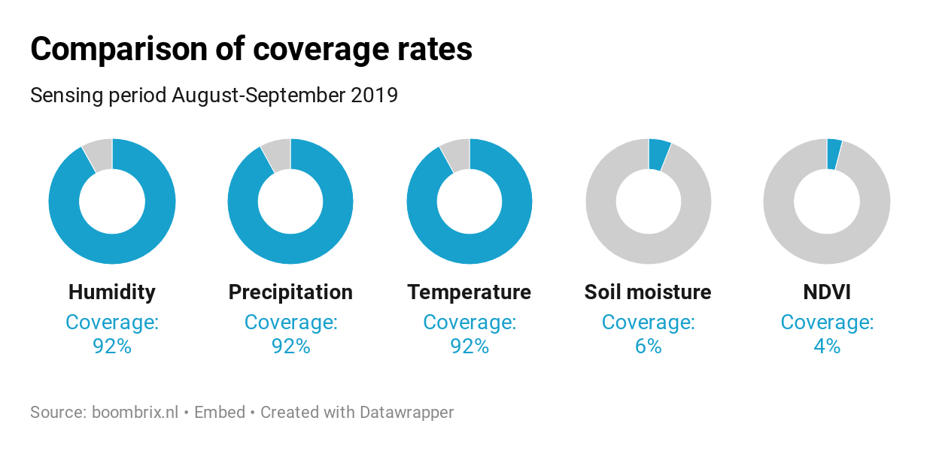
Available datasets offered different level of data coverage with meteorological data scoring the highest (92%) and site specific measurements scoring the lowest (soil moisture - 6%, NDVI - 4%).

Comparison of precipitation and soil moisture in the period with best soil moisture data coverage
Taking into account the primary goal of the investigation which was determination of soil moisture response to the precipitation we highlighted period with the best coverage of soil moisture data - 18/09 to 02/10/2019.
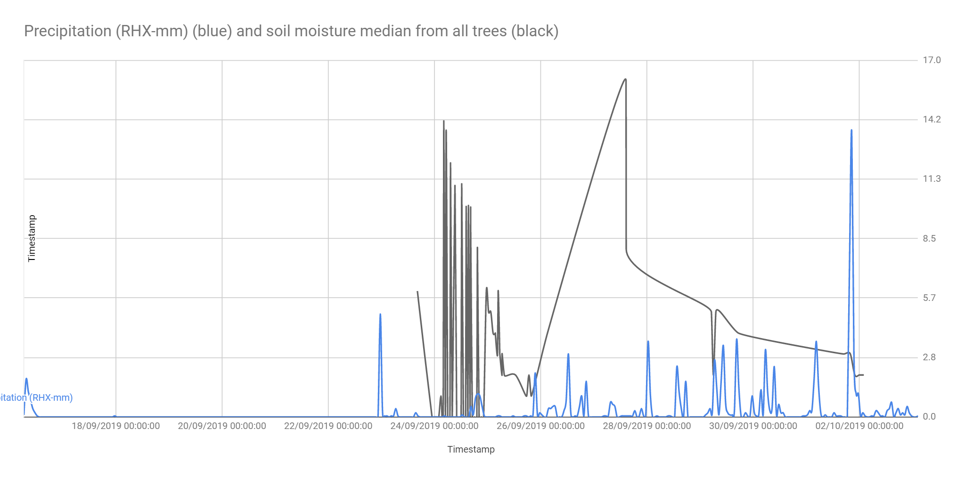

Windows before soil moisture response
Based on the available data we established that 24 to 36 hours after event of rain there is response from soil moisture devices installed on the site. Similar timeframe could be observed for drop in soil moisture after the rain stops. Although preliminary those results give us an idea of the time which is needed for absorption of water in case of pilot’s location.

Distribution of soil moisture per device/tree
Collected data allows us to see differences between soil moisture values between different trees chosen for the pilot. Data from 7 out of 9 trees had met conditions for further analysis although we need to state that usable data was achieved for 5 of them.
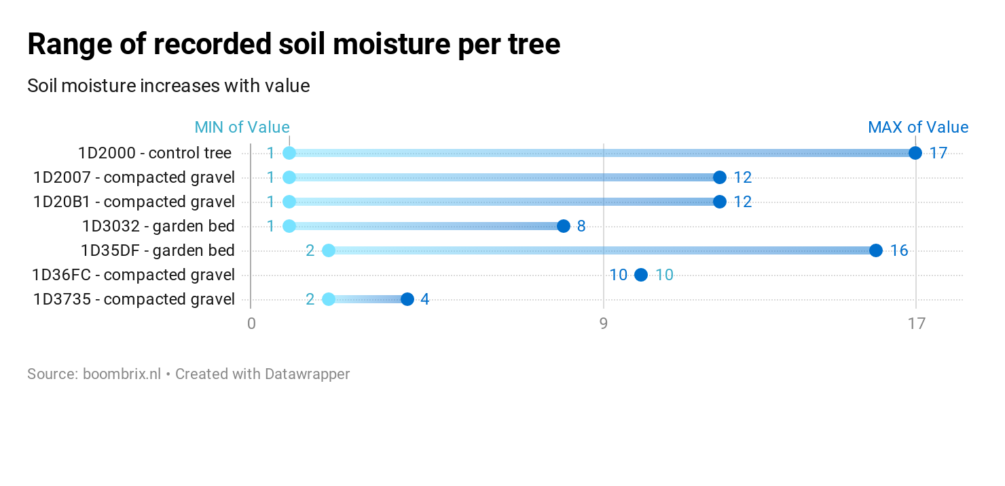
Usual ranges of soil moisture are 2-5, 3-14, 2-3, 4-6 and 2-5.
Tree with the highest range - biggest level of soil moisture - is tree with municipality ID 340996 which is higher (9-12 m) then other trees in the set (6-12 m) and is the control tree.
We cannot establish definitive direct link between these information but it could be interesting to use this observation as input for the design of further research.

Proportions in soil moisture on different sensing levels
Based on collected data we found 6 out of 9 trees feasible for analysis of proportions in soil moisture levels between different depths of tree pit.
Interestingly tree with device id 1D20B1 and abnormal distribution of soil moisture between depths of tree pits was scoring 3 out of 6 times as a tree with the lowest level of NDVI.
We cannot establish definitive direct link between these information but it could be interesting to use this observation as input for the design of further research.
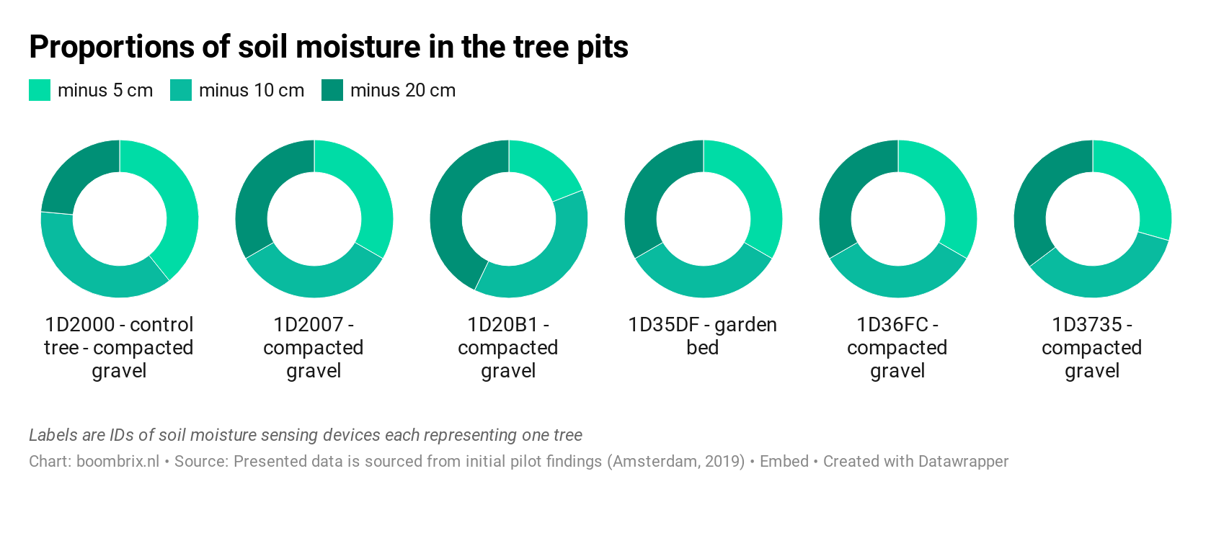

NDVI results
For the purpose of this report we used results for remote sensing observations in August and September 2019 with maximum cloud cover of 30%.
Key finding is different in response to same atmospherical conditions which can be seen for groups of trees in the pilot area. Based on this data we can state that on average trees with garden beds had better NDVI that those with compacted gravel.
These findings are not definitive but are valuable input for the design of further research.
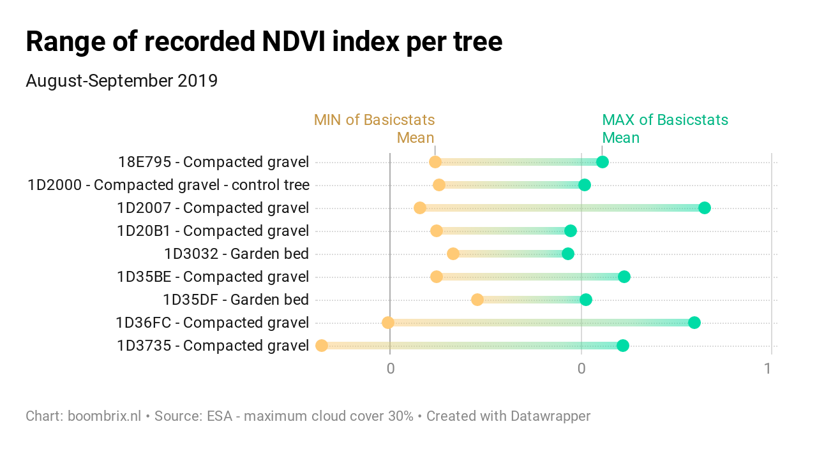
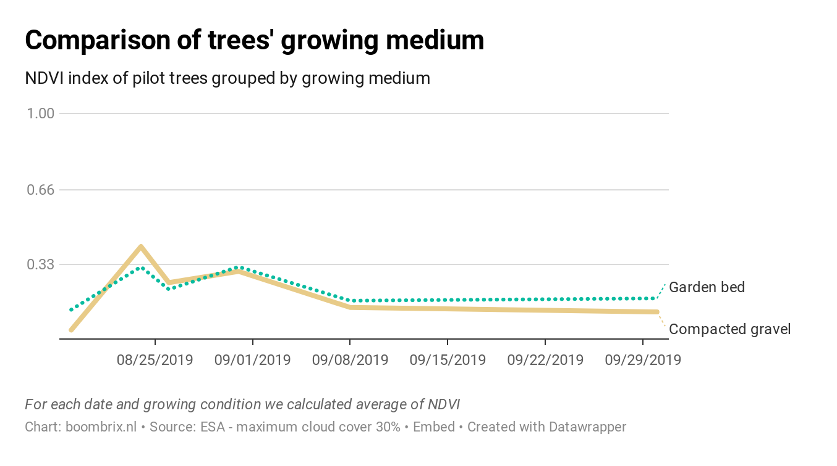

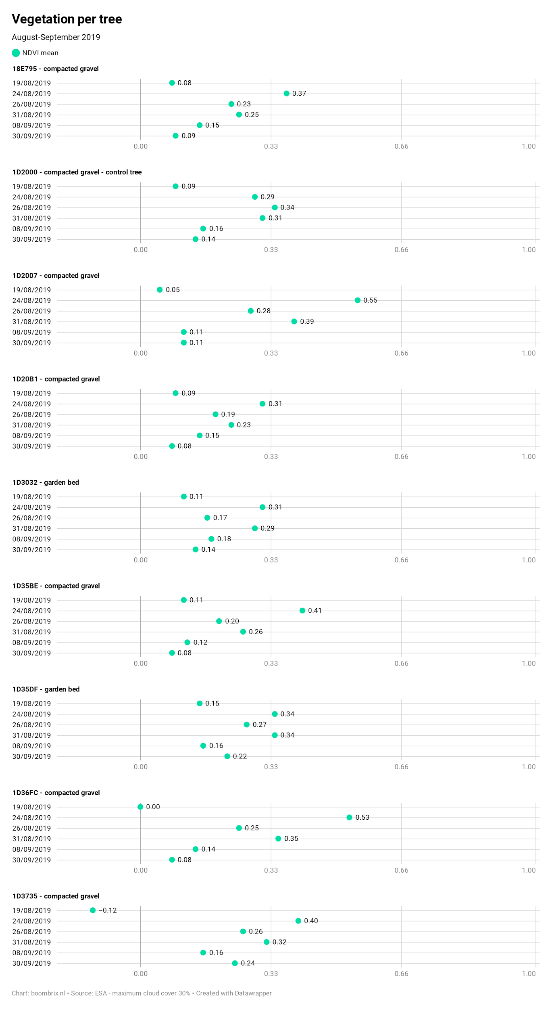

Pilot sensing
The purpose of the pilot in the SiRA programme was to test how the use of a startup’s product/service could benefit the municipality in the future. As part of the pilot plan, a list of criteria were created by Boombrix and coordinated with the case owner. The results of these criteria is summarised in the table below:
Pilot vision criteria | Y | N
Collected data allows for drawing the conclusions on additional watering of trees | ×
Sensing unit is able to continuously collect data for more than four weeks at a time. |  | ×
Data on soil moisture can be used to gain insights during watering/rainfall events in combination with covariate temperature and vegetation data | ×
Data on soil moisture provides insights to existing growing conditions and necessity for three depths of sensing. |  | ×
Data on soil moisture can be delivered to the client in a legible format. | ×

The prototype soil moisture device encountered challenges during the Rapenburgerstraat pilot. This resulted in irregular device readings that are attributable to the increased number of sensors connected to the same microcontroller. Nevertheless, the process of installing the units and the data that was obtained provided Boombrix with insights into the barriers to ensuring the trees are provided with sufficient water.

Relevance to current environmental issues and policies
The findings from the SiRA pilot project can contribute to the current policies of the municipality. Specifically, four of the “Structural Vision 2040” vision thrusts: increasing the resilience and extents of landscapes, maintaining a high quality landscape, and maintaining a high quality of trees in recreational and business growth areas.
As the municipality of Amsterdam seeks to expand and improve upon its green infrastructure, it is important to understand what growing conditions and maintenance practices can be improved to increase the longevity of trees in the city.
In addition to policy, the findings of this report can assist in the planning and expansion of “greening” initiatives like the biodiversity planting found along the pilot street. Increasing biodiversity via these garden beds is also connected to the “Rainproof Amsterdam” initiative by Waternet and the municipality of Amsterdam: more garden beds instead of paving can assist in better stormwater management in the city.

Conclusions from the SiRA pilot project
The conclusions from the SiRA pilot project are divided into topics and are set out in the following subsections.

Redefining the challenge “Trees in need”
The “Trees in need” challenge began as a challenge that was focused on watering and reducing the risks of tree failure. The aims of this challenge still remain relevant to the municipality’s targets towards becoming more circular and climate-resilient. Boombrix and the SiRA programme have added definition to the challenge and its possible solutions. To add definition to the “Trees in need” challenge it is recommended that the following insights be considered:
- Watering is a challenge for areas that are manually irrigated by the municipality. For the majority of areas that are not, ensuring better growing conditions is more useful to tackling drought and heat.
- The growing conditions of the trees should be reviewed to better understand if the problem lies with a lack of water or a lack of infiltration of water to tree roots.
- Threats to tree health due to watering are potentially as urgent as threats due to invasive pests and diseases. As yet there is no way to accurately and remotely sense infestation or infection. The challenge of pests and diseases is also a human resource challenge when detection depends on specialist consultants or interested citizens.
Actionable outcome: Include all threats to the resilience of trees when describing the “Trees in need” challenge.

Redefining “at risk” trees
The “at risk” tree register provided Boombrix with insights into the case owner’s database of tree information and how it is used to assess the potential threats to tree health. Once the pilot commenced however, it became clear that the “at risk” trees may not actually be at risk and that more refinement may be needed to identify “at risk” trees.
In the appendix is a comparison of the method used by Boombrix to create a shortlist of “at risk” trees showing that there were no “high risk” trees in the pilot site. What was inaccurate in the Boombrix identification was the status of the trees situated in garden bed - we know from the results that they appear to perform better than trees in gravel.
Therefore, further research is required into the ways in which “at risk” trees can be identified or if it is possible at all. The pilot project demonstrated that on site factors can greatly affect the resilience of a tree and that this data is not represented in municipal or publicly available datasets.
Actionable outcome: Tree growing conditions should be registered in the tree database to improve assessment of “at risk” trees.

Improving tree growing conditions
The pilot results demonstrate the importance of growing conditions for the effective infiltration of water to the tree’s root zone. The cementitious gravel surface that has been applied to most of the pilot tree pits appears to cause inconsistent distribution and movement of water through the soil horizon. In addition to this, when installing the devices in the tree pit it was noted that there was no visible soil biota present in the upper layers of the soil.
In addition to the surfacing and soil mix, tree growing conditions are also affected by the misuse of aeration equipment that has been installed for some trees. As witnessed together with the case owner during inspections through the city, these PVC pipes are frequently blocked by rubbish or are damaged by daily activities around the tree. It was also interesting to note that the PVC pipe did not have an immediately clear use with some maintenance teams using the pipe for watering. These findings in combination with previous years’ droughts highlights the importance of ameliorating growing conditions and correct maintenance procedures
The pilot trees that were located in garden bed were observed to perform better in the NDVI readings. It is also notable that there was visible soil biota and higher organic matter present in the upper layers of the garden bed soil. It is recommended that further study be undertaken to quantify the watering benefits that garden beds provide for trees in the city.
Actionable outcome: Reconsider cementitious gravel surfacing on tree pits and increase knowledge about correct use of tree pit equipment (like PVC pipes).

Potential in participation and education
The challenge to improving tree longevity includes education and changing the behaviours of citizens and city-dwellers whose daily actions can impact upon a tree’s ongoing health
In the course of pilot deployment we encountered a lot of positive attention from the members of the general public and pilot location inhabitants. One of them was a group of children aged 4-5 with their grandmothers who for more than half an hour accompanied us and observed installation of the sensors. Part of this experience was also explaining the logic behind the project and technology which we used to implement it.
This experience provided us with the idea to approach participation in sustainability projects not only at the level of insights and information but also in engaging the general public in the installation which might balance interest of different groups of citizens and lead to engagement of the ones currently not interested.
Actionable outcome: consider expanding groups eligible for existing neighbourhood greening initiatives (e.g.: green subsidy).
  - Future areas of product improvement and development
At the conclusion of the pilot project Boombrix and the case owner reflected upon the pilot activities and results with the aim of identifying areas for further development and improvement. The points for development and improvement were as follows:
- Connection with other sensors and forms of data in the city should be investigated
- Investigation into optimal sensing period - how to determine it, on what basis, how it changes the method and results
- How to connect sensing and reporting to the long-term planning of the municipality
- How to use sensors to enable City of Amsterdam to have better insights into conditions of the trees they take over from contractors for maintenance
- Potential to investigate conditions of trees planted on top of the parking garages
- Potential to investigate why trees are not growing in the expected pace
- Improve methodology for designating risk trees
- Potential to investigate salinity of the soil/ground water in Amsterdam

Conclusions
Startups like Boombrix have an opportunity - through the SiRA programme - investigate and test innovative solutions for sustainability challenges in Amsterdam. Boombrix together with stakeholders involved in the “Trees in need” challenge have - in less than nine months - been able to closely analyse the processes that affect the amount of water that a tree can recieve with or without manual irrigation.
The SiRA pilot project results indicate that further research is needed by Boombrix and the case owner to better identify which trees are vulnerable and what indicators of vulnerability can be sensed by Boombrix. It is anticipated that a second pilot will be proposed at a later time after a period of research and development.
In the near future however it is suggested that the “actionable outcomes” from the conclusions be undertaken by the municipality to improve the resilience Amsterdam’s trees via slight modifications to their physical context and maintenance practices.

Part B – SiRA component

Startup In Residence Amsterdam (SiRA) program
Startup in Residence program is an idea of procuring innovation by enabling contact between case owners from the City of Amsterdam and start-ups with original ideas. Each start-up answers to the challenge issued by the municipality and after admission works towards adjusting it to the needs of the case owner while trying to maintain the highest quality possible.

Boombrix and the SiRA pilot project
After admission to the programme Boombrix team attended all of the 23 trainings and met with case owner 15 times. Beside that we conducted on-site study before completion of the programme at the end of November.

Boombrix and the “Trees in Need” SiRA challenge
For a startup to be selected for the “Trees in Need” challenge, applicants were required to meet the criteria set by the issuing department: prior knowledge of trees in an urban environment; a proposal for assisting in determining when and where a tree must be watered. Additional criteria included potential integration for water recycling, potential citywide application scale, and ensuring that proposed objects are vandal-proof. When the criteria were met, the selected startup would develop and test their product and/or service to support the aims of the challenge.
Boombrix were the successful applicants for the “Trees in Need” challenge and began working together with the challenge case owner - Jaike Bijleveld from the Asset Management, Traffic and Public Space department - in May 2019. Being selected for the SiRA programme gave Boombrix the necessary setting to test its product and service: an “Internet of Things” (IoT) soil moisture device that collects data that enriches existing urban data that can be used to provide weekly or monthly insights to clients.
Both startups and case owners were provided with training and were encouraged to meet to discuss how the startup could shape their business towards the aims of the Municipality of Amsterdam. In the case of Boombrix this was an opportunity to understand more about the routines and departments that influence the health of the trees in Amsterdam. These discussions led Boombrix to reconsider elements of the business model that, with the knowledge and experience of the SiRA programme, caused Boombrix to shift towards a service-oriented business that can potentially better respond to the changing needs of the trees in cities.
At the conclusion of the pilot it became clear that further research and development was required and, where possible, future pilots with the municipality to test and refine the service.

Trees in need: SiRA findings

Innovation in tackling urban sustainability challenges
Innovative approach in tackling urban sustainability challenges is one of the crucial instruments that can be used. In our case we could see how important it is to have open discussions with case owner not only because of the financial aspect itself, but most importantly to understand issues which need to be solved first. Complexity of sustainability issues and their different definitions require having open platform for exchange of ideas and interpretations of the real world challenges. Having said that, it is important to stress that answer to this complex issues might come in many forms which also need to be assessed wisely as not to create new problems once implemented. In our opinion environment of Startup in Residence Programme and commitment from the case owner allowed for this considerations not only to happen but also to shape final setup of the pilot.

Value of SiRA training in the case of Boombrix
Our project and team developed in numerous ways including pivoting initial idea, fine-tuning original market, increasing our range of soft and hard skills, networking with fellow start-ups, mentors and stakeholders and last but not least conducting pilot with 9 trees in real-life conditions of Amsterdam street.

Value of SiRA case owners
Benefits of the SiRA programme extend to case owners and municipal departments that have the opportunity of having a startup dedicate their activities towards addressing sustainability challenges. While the goal of the SiRA programme is not to limit startups’ products/services to Amsterdam, the 2019 sustainability challenges – especially in the case of “Trees in Need” – are faced by municipalities and private companies around the world. In this sense the value for case owners is to have the opportunity to inform the products/services that are being developed so that the startup’s solutions can be better integrated with municipal operations.

Challenges to startup activities in the SiRA programme
The Startup in Residence’s sustainability-focused challenges present a unique opportunity for the municipality and startups to quickly assess and tackle urban sustainability challenges. From the experience of Boombrix there are areas of the programme that can be developed to better address:
- Awareness of required time commitments by the case owners and their department contacts – this is required for stakeholder/customer analysis and pilot activities;
- Guidance on the contracts and legal agreements for the pilot and future works with the municipality;
- Navigation of municipal departments that are necessary for performing pilot projects (e.g.: having contact and guidelines from municipal data officers);
- Navigation of municipal practices and how they have changed in recent years with the restructuring of the municipality.
The above list is not exhaustive and highlights only the major challenges faced by Boombrix. Since the official completion of the SiRA programme in 2019, feedback sessions organised by the SiRA team have taken place with a view to adjust the SiRA programme where possible to minimise the occurrence of these challenges.

Summary of findings and recommendations
In the future timing of the programmes regarding sustainability and environment could be decided according to the seasons of the year. With challenge taking into account issues like soil moisture, drought, vegetation window performing pilot is limited to part of years when it is possible and sensible to make measurements. In case of our pilot we were able to perform measurements in last months of summer but we already know that to fully assess our technology we would need more time in spring and summer periods of year.
In terms of programme itself it would be very helpful if programme wouldn’t end after 6 months but had some form of support for startup and case owner over a whole procurement window of 4-5 years. This support could be instrumental in making scaling up of the project possible and ensuring that knowledge from the 6 months of training is fully used.

Appendices
1. Boombrix, Project Plan prepared for Startup In Residence program. Issued 8th August 2019.
2. Municipality of Amsterdam, Startup In Residence Tender “Trees in need” challenge description.
3. SiRA pilot resources
4. Boombrix device analysis
5. “At risk” trees: comparison of identification method

Boombrix, Project Plan prepared for Startup In Residence program. Issued 8th August 2019.
[PDF will be placed in here]

Municipality of Amsterdam, Startup In Residence Tender “Trees in need” challenge description.

Extract from “Request for Tender Startup in Residence Sustainability Programme”, issued by Gemeente Amsterdam, version 1.0, document number AIS-2019-0001.
Background With more than a million trees, Amsterdam is one of the greenest cities in Europe. The trees aren’t just there for aesthetics – they’re also crucial to climate proofing: they cool the air, take up rainwater and have a positive effect on wellbeing, health and biodiversity. On a hot day, one tree has the same cooling effect as ten air-conditioning units. Because trees are so valuable to Amsterdam and its inhabitants, they’re managed to keep them safe and healthy for as long as possible.
Because of climate change, we are experiencing more extreme weather conditions, and this can drastically shorten the lives of assets like trees, bridges and canal sides. Asset management concentrates on maximising the lifespan of assets, and that also applies to trees. And so, Amsterdam is working to ensure that trees are future proof, and that the city stays pleasant and liveable in a way that keeps the costs low. Various initiatives have already been launched, such as the Rainproof programme, aimed at coping with increasingly heavy rainfall. Drought is another topical climate issue: temperature and drought records were broken over and over again in 2018. We know that trees help to make the city heatproof, but how can we make the trees themselves heatproof?
During the drought in the summer months of 2018, the city districts spent €475,000 on watering plants and trees – around €160,000 a month. At a first rough estimate, because of the drought, the city has lost between 25 to 50 per cent of its planting (shrubs, perennials, hedges, new trees and lawns that are heavily used and are not watered, as in the Vondelpark and Sarphatipark). The cost of replanting next year is estimated at around €1.4 million euros. A more accurate estimate can only be made in spring, when we see whether apparently lifeless plants start putting out new shoots. However, another period of drought or a hard winter could finish plants off. Apart from the initial expense of replanting, there will also be extra maintenance costs, because new planting needs more weeding and watering.
We’re looking for innovative solutions that enable the trees themselves to ‘express their needs’ so that ultimately we can provide customised care to individual trees. The aim is to enable trees to grow bigger and older, so they’re more attractive and more valuable to the city.
The Challenge: Develop an innovative solution to enable trees to ‘express their needs’.
Criteria: - We’re looking for a solution that will indicate and register exactly when a tree really needs water: ‘give the tree a voice’. - Circular solutions are preferred – for example, collecting rainwater during heavy showers to prevent flooding and using it to water trees during periods of drought. - Startups that at least have some knowledge of trees in an urban environment are preferred. - It should be possible to roll the solution out across the entire city, and it should be vandal proof.
Aims: - Tree care in times of drought that is sustainable (no water wastage), efficient (targeted) and effective (amount of water per tree). - Circular tree management (water recycling). - Future-proof tree management (such as planting trees that are less sensitive to extreme weather conditions). - Data collection for risk management. - The tool must be affordable to use within the regular maintenance budget. - The City of Amsterdam aims to ensure that by 2025 all public space will have the status of ‘well maintained’. This means that at a given location, no more than 10 percent of certain assets in public space may be classified below CROW standard B.
Issued by: Assetmanagement, Verkeer en Openbare Ruimte.

SiRA pilot resources
The pilot project was made possible by drawing upon resources from Boombrix and the Municipality. The allocation of resources was determined by what was available to Boombrix and the Municipality within the period of the SIRA program. The resources listed in the table below formed the basis for the pilot’s activities and results.
Resource type | Description
Human | Noelle Teh and Jakub Supera (Boombrix co-founders)  Jaike Bijleveld (Case owner)  Ilona Kemps (SiRA program team lead)  Marc Oerlemans, Hans Kaljee, Jeroen van Kemenade (Case owners’ participating stakeholders)  SiRA mentors  Municipal contracts team
Technical | Municipal data (open and restricted access)  IoT enabled devices and network access  Arduino compliant hardware and software  Document and data processing software
Economic | Boombrix financial investment (from co-founders only)  Municipal funds allocated for SiRA program (paid at completion)
Table: Pilot project resources
Given the available resources, the pilot project’s planning and activities depended on - and benefited from - a high degree of human resources as demonstrated by the case owner’s time spent in fortnightly meetings with the Boombrix team. During implementation stage the Boombrix team drew upon its own technical and economic resources which minimised resource costs to the municipality.
Finding: The SiRA program pilots benefit from ensuring that at a minimum human resource are made available by startups and municipal teams.

Boombrix device up-scaling analysis

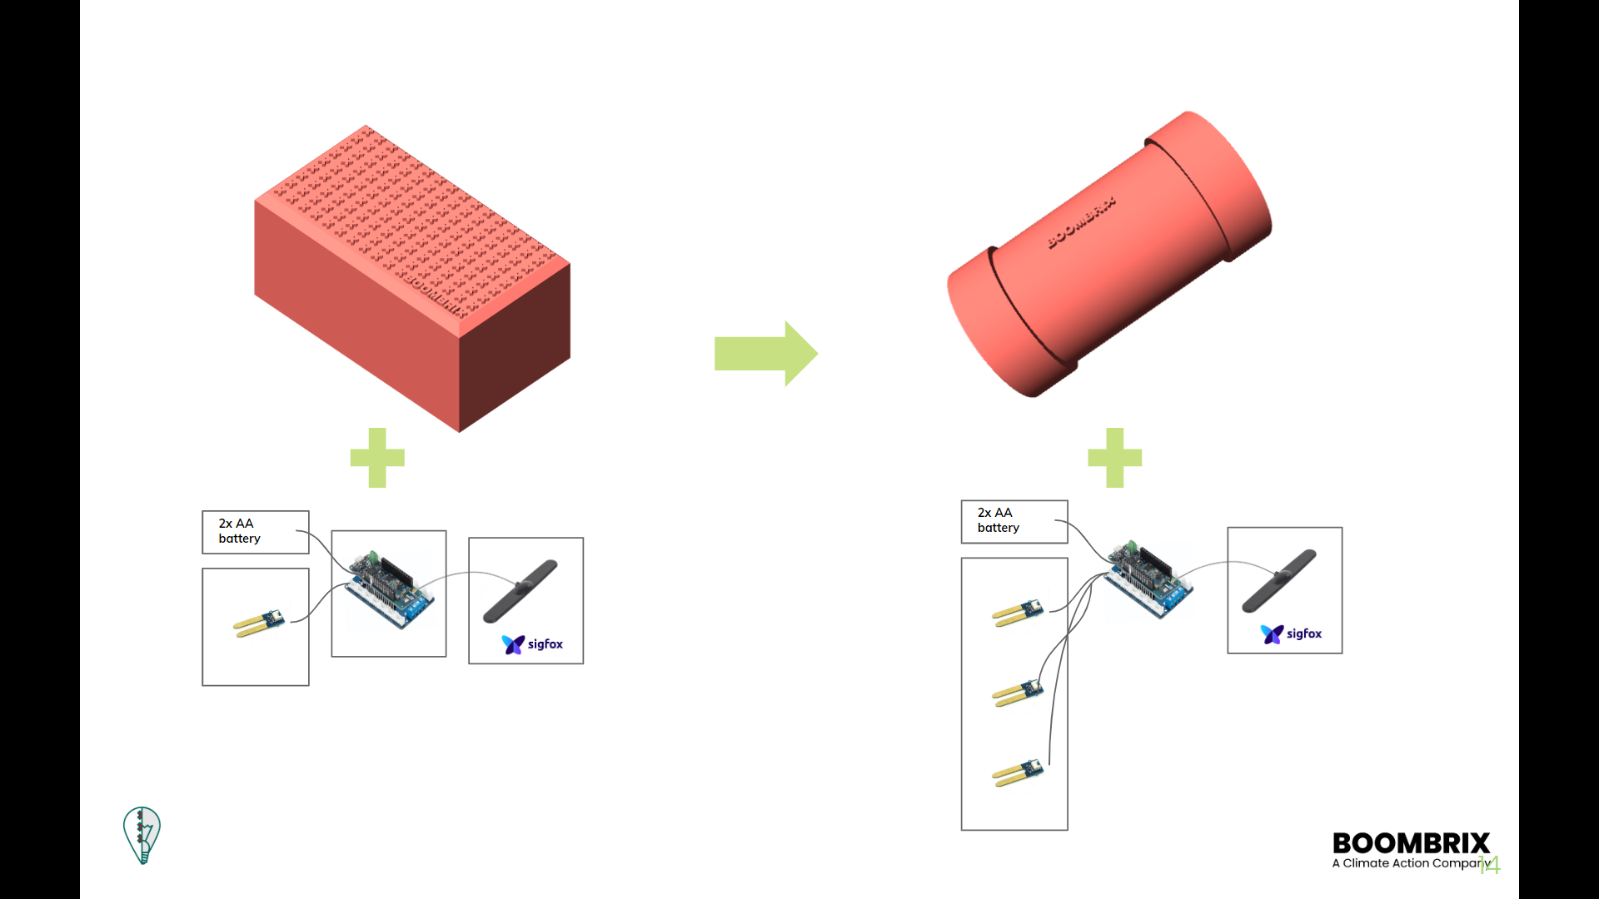
As the response to updated list of conditions and requirements for vandal-proof design we changed the design of our soil moisture sensing unit.
Unchanged:
Power source, Arduino SigFox motherboard, GSM antenna, sensor technology
Changed:
Number of sensors: from 1 to 3
Casing: from brick shape to insulated vandal-proof tube

“At risk” trees: comparison of identification method
The Boombrix method of identifying “at risk” trees is based on spatial data that is publicly available via the Municipality’s open data website. As previously outlined the “at risk” trees from the Municipality are identified based on age, DBH, and guarantee period whereas the Boombrix “at risk” trees are identified based on their immediate surroundings and growing conditions – presence of paving, surface slope, exposure to the urban heat island effect, and soil quality.
Using the pilot neighbourhood as an example the two “at risk” trees are shown in the map diagrams below:
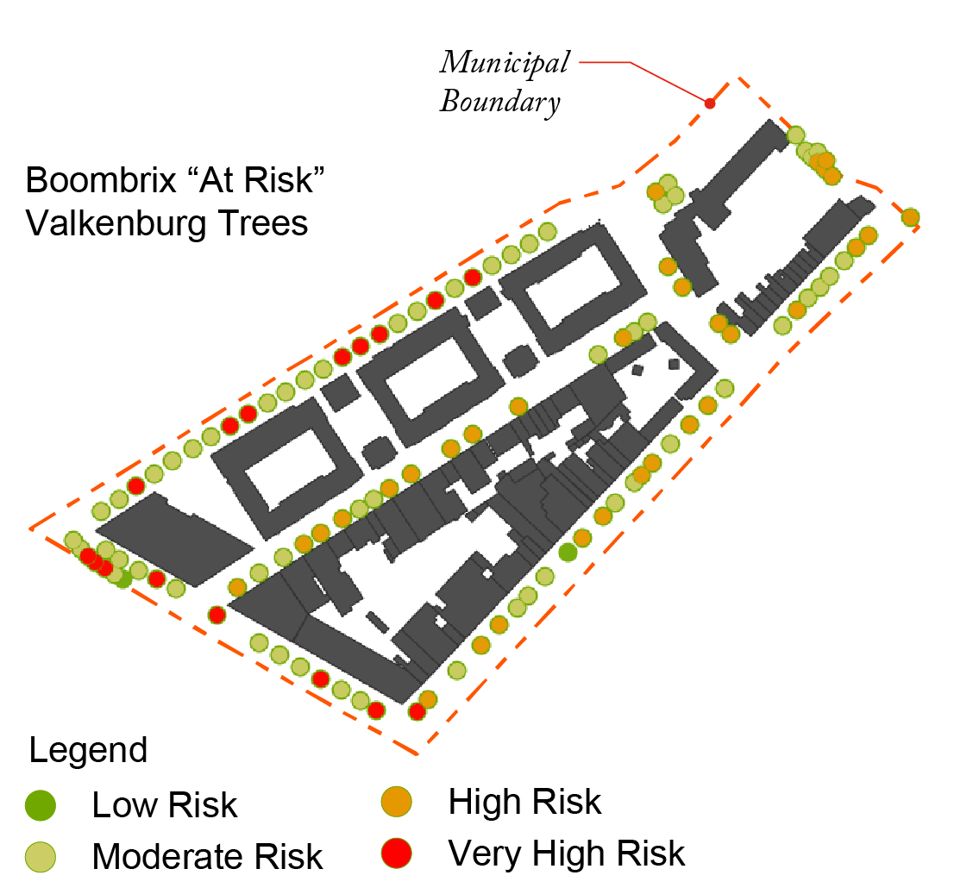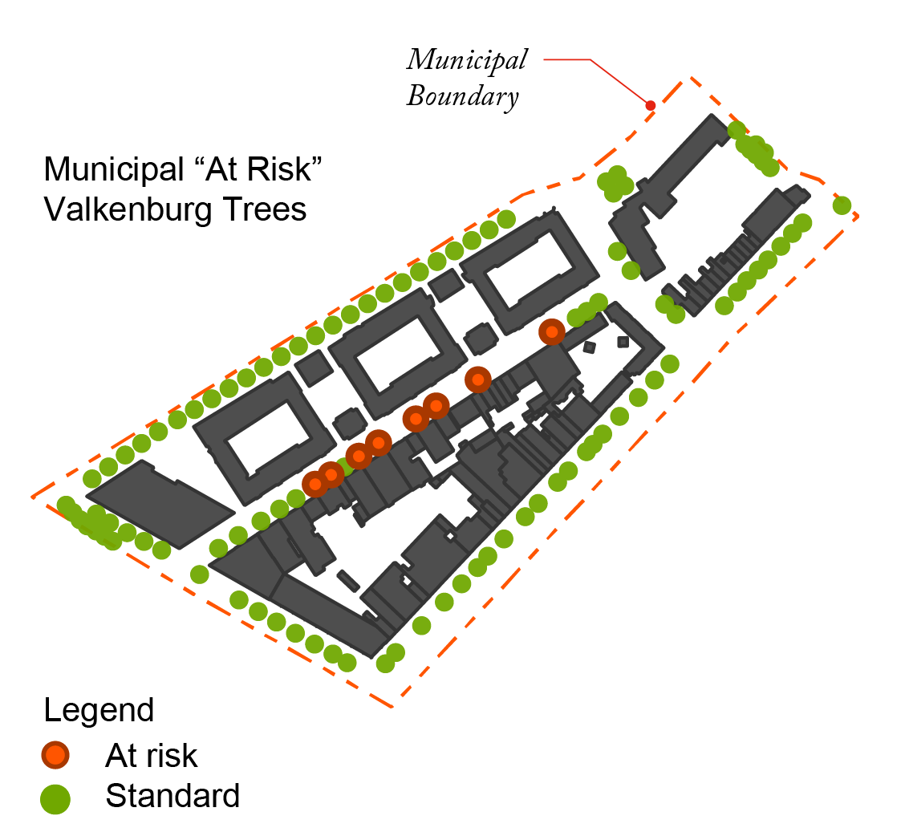
Conclusion: the accuracy of identifying urban trees that are “at risk” requires further research and refinement. It also reveals that the quality of data from the client can play an important role in the ongoing identification and monitoring of “at risk” trees and both methodologies should be combined whenever data is available.

